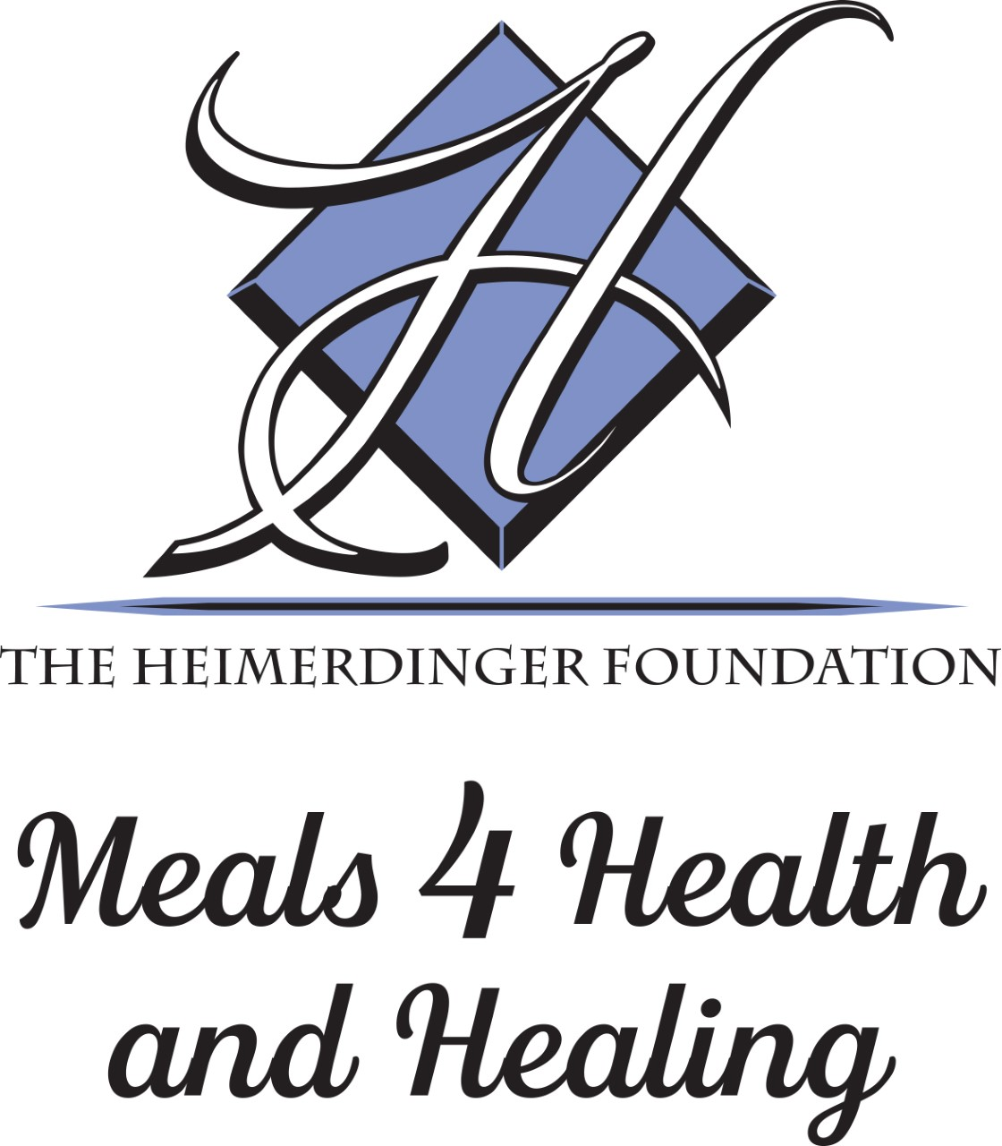

TEEN VOLUNTEER APPLICATION

NAME:__________________________________________________________ Date: __________________________
ADDRESS: _______________________________________________________________________________________
CITY: _______________________________________ STATE: ___________ ZIP: ______________________________
PHONE:____________________________________EMAIL: _______________________________________________
SCHOOL _________________________________________GRADE __________ DOB:___________________________
Ethnicity: ( ) Caucasian ( )Asian ( )Hispanic/Latino ( )African American, Other ________________________
PARENT INFORMATION
NAME:_________________________________________ NAME:_______________________________________
ADDRESS: ______________________________________ ADDRESS: ____________________________________
CITY: __________________ST: ______ZIP :__________ CITY: __________________ST: _____ZIP :__________
PHONE NUMBER________________________________ PHONE NUMBER_______________________________
EMAIL: _________________________________________ EMAIL: _______________________________________

Why do you want to volunteer with The Heimerdinger Foundation? (check all that apply)?
_____ to cook _____ my friends volunteer at Meals 4 Health and Healing
_____ to learn to cook _____ my parents want me to volunteer
_____ to learn about healthy foods _____ school community service hours
_____ to help people _____ a friend or family member received the meals
_____ other: _____________________________________________________

Emergency Medical Release Form
This form is required for participation in Meals 4 Health and Healing. Complete each section thoroughly, sign and date.
Teen’s Name_____________________________________________Date: ___________ LAST FIRST MIDDLE
Sex: [ ]F [ ]M Age ______ Birthdate (MM/DD/YYYY) _____________________________
Parent Name: ________________________________________Cell Phone _______________________
Parent Name: ________________________________________Cell Phone _______________________ Additional person authorized to pick up my child and or in case of an illness or an emergency:
________________________________________________________________________
NAME RELATIONSHIP PHONE
Does your child have any allergies to food, medications, insects etc.? [ ]Yes [ ]No
If yes, please list: ________________________________________________________________
Does your child currently or in the past have any medical conditions that we may need to know about that would impact their work in the kitchen, or in case he/she needs treatment? [ ]Yes [ ]No
If yes, please explain: ________________________________________________
In case of emergency, take my child to the following hospital (please check one):
[ ] Nearest hospital OR [ ] _______________________ (name of hospital)
Emergency Release
If, in the judgment of the staff of Meals 4 Health and Healing, the child named above needs immediate care and treatment as a result of any injury or sickness, I hereby give permission to the staff to secure proper treatment for my child. I do hereby consent to whatever x-ray, examination, anesthetic, medical, surgical, or dental diagnosis or treatment and hospital care are considered necessary in the best judgment of the attending physician, surgeon, or dentist and performed by or under the supervision of the medical staff of the hospital or facility furnishing medical or dental services. It is further understood that the undersigned will assume full responsibility for any such action, including payment of costs. I do hereby agree to indemnify and hold harmless Meals 4 Health and Healing (including its officers, directors, staff members, and/or volunteers) from any claim by any person whomsoever on account of such care and treatment of said child.
_________________________________________________________________________
PRINT FULL NAME OF PARENT, GUARDIAN SIGNATURE DATE

Volunteer Agreement and Release From Liability
- I, _______________________________________________ (print name), agree to volunteer for The Heimerdinger Foundation, a Tennessee nonprofit corporation and/or its program Meals 4 Health and Healing.
- I am aware that participation as a volunteer may require periods of standing, lifting, and carrying up to 40 pounds and will require the exercise of reasonable care to avoid injury. I am voluntarily participating in this activity with knowledge of the hazards and potential dangers involved, and agree to accept any and all risks of personal injury and property damage.
- I do hereby grant permission to The Heimerdinger Foundation, Inc., the Meals 4 Health and Healing program and/or its designated representative to permit my picture to be taken, or likeness reproduced and disseminated via various media and/or communication vehicles such as local newspapers and the Foundation website, or to be otherwise utilized by the Foundation in regard to the Foundation’s approved events and activities including use of name, voice, and/or writings and reproductions of the same in any form. I hereby release the Foundation and any of its officers, directors, employees, agents, and volunteers from liabilities arising out of what I might deem misrepresentations by virtue of distortion, optical illusions, or faulty mechanical reproductions. The publicity I shall receive by virtue of the first such use that may be made thereof shall be full and adequate compensation for this consent. I agree all such uses of my name, voice, likeness, portraits, pictures, photographs, films, videotapes, audiotapes, or writings and reproductions thereof, including but not limited to tapes, plates, and negatives connected therewith are and shall remain the property of The Heimerdinger Foundation, Inc and/or its designated representative.
- As consideration for volunteering for the Heimerdinger Foundation, I hereby agree that I, and my assignees, heirs, guardians, and legal representatives will not make a claim against or sue the Heimerdinger Foundation or its employees, agents, or contractors for injury or damage resulting from the negligence, whether active or passive, or other acts, however caused, by any of its officers, employees, agents, or contractors of The Heimerdinger Foundation as a result of my volunteering. I HEREBY RELEASE AND DISCHARGE THE HEIMDERDINGER FOUNDATION AND ITS OFFCIERS, EMPLOYEES, AGENTS, AND CONTRACTORS FROM ALL ACTIONS, CLAIMS, OR DEMANDS THAT I, MY HEIRS, GUARDIANS, AND LEGAL REPRESENTATIVES NOW HAVE, OR MAY HAVE IN THE FUTURE, FOR INJURY OR DAMAGE RESULTING FROM MY PARTICIPATION AS A VOLUNTEER.
- I UNDERSTAND THAT IF I AM INJURED IN THE COURSE OF VOLUNTEERING, I AM NOT COVERED BY THE HEIMERDINGER FOUNDATION. If volunteering for the Meals 4 Health and Healing program to work in the kitchen, I SPECIFICALLY UNDERSTAND THE RISKS OF INJURY WORKING IN A KITCHEN SUCH AS KNIFE CUTS AND BURNS I authorize the Heimerdinger Foundation to seek emergency medical treatment on my behalf in case of injury, accident, or illness to me arising from my involvement as a volunteer. I have provided the Heimerdinger Foundation with a current updated emergency medical release form. I understand that I will be responsible for medical costs incurred by such accident, illness, or injury.
- I understand that all client lists, volunteer lists, menus, recipes, and any other of the materials or tools provided by Meals 4 Health and Healing are and remain the property of Meals 4 Health and Healing. I agree that I may not use any of the property of Meals 4 Health and Healing for personal or business gain, and I agree to return any tools and any remaining materials to Meals 4 Health and Healing at the end of my volunteer service.
- I HAVE CAREFULLY READ THIS AGREEMENT AND FULLY UNDERSTAND ITS CONTENTS. I AM AWARE THAT THIS IS A RELEASE OF LIABILITY, AND SIGN IT OF MY OWN FREE WILL.

DATE PARENT/GUARDIAN SIGNATURE PRINTED NAME
If volunteer is under 18 years of age, parent or guardian must read and sign. This release, its significance, and assumption of risk have been explained to and are understood by the minor. I UNDERSTAND BY SIGNING AS THE PARENT/GUARDIAN I AM RELEASING LIABILITY AND APPROVING PARTICIPATION BY THE VOLUNTEER ACCORDING TO THE LANGUANGE ABOVE.

Confidentiality
Thank you for volunteering for The Heimerdinger Foundation Meals 4 Health and Healing Program.

I _________________________, agree to keep confidential all client information or otherwise private information of The Heimerdinger Foundation Meals 4 Health and Healing Program.

